Gelei Chen

Stage 1

|  |  |
| --- | --- |
| RRinc | Running POP |
| 82 | 0.8525211 |
| 85 | 2.5007576 |
| 87 | 3.0197141 |
| 99 | 3.1777041 |
| 104 | 3.3669369 |
| 119 | 3.8287614 |
| 133 | 5.4769979 |
| 136 | 14.7501283 |
| 147 | 15.0417849 |
| 157 | 96.9589945 |
| 165 | 107.492241 |
| 166 | 108.893336 |
| 167 | 114.019932 |
| 174 | 114.177922 |
| 177 | 115.030443 |
| 178 | 127.704527 |
| 180 | 129.352764 |
| 185 | 139.358996 |
| 196 | 154.267859 |
| 203 | 219.034697 |
| 205 | 219.223929 |
| 207 | 301.141139 |
| 210 | 322.100385 |
| 212 | 331.373516 |
| 213 | 341.906762 |
| 221 | 347.033358 |
| 230 | 361.355679 |
| 233 | 362.046396 |
| 235 | 373.031894 |
| 238 | 376.389107 |
| 248 | 458.306316 |
| 255 | 466.119641 |
| 256 | 476.652888 |
| 257 | 476.810878 |
| 266 | 489.484962 |
| 268 | 494.611558 |
| 269 | 587.654655 |
| 277 | 597.660887 |
| 280 | 599.617005 |
| 281 | 600.469526 |
| 283 | 602.117762 |
| 284 | 602.579587 |
| 285 | 684.496796 |
| 291 | 712.742588 |
| 298 | 723.275835 |
| 300 | 735.949919 |
| 301 | 736.139152 |
| 303 | 737.540247 |
| 306 | 737.875247 |
| 314 | 743.001843 |
| 315 | 805.812563 |
| 316 | 815.818795 |
| 321 | 897.736004 |
| 324 | 918.695251 |
| 326 | 929.924499 |
| 331 | 935.781706 |
| 336 | 936.951138 |
| 337 | 949.625222 |
| 340 | 963.349793 |
| 343 | 970.546746 |
| 344 | 971.820087 |
| 346 | 973.468324 |
| 352 | 973.626314 |
| 355 | 983.632546 |
| 357 | 1046.44327 |
| 360 | 1128.36048 |
| 361 | 1133.48707 |
| 364 | 1134.88817 |
| 375 | 1136.84428 |
| 377 | 1149.51837 |
| 381 | 1170.47761 |
| 387 | 1173.34296 |
| 388 | 1183.87621 |
| 390 | 1193.14934 |
| 392 | 1221.39513 |
| 395 | 1221.58436 |
| 398 | 1231.5906 |
| 402 | 1232.44312 |
| 403 | 1295.25384 |
| 404 | 1377.17105 |
| 410 | 1383.02825 |
| 414 | 1388.94061 |
| 423 | 1390.58885 |
| 425 | 1403.78189 |
| 427 | 1405.73801 |
| 428 | 1407.82982 |
| 439 | 1415.93083 |
| 440 | 1442.42713 |
| 444 | 1452.96037 |
| 447 | 1462.96661 |
| 453 | 1525.77733 |
| 455 | 1527.43723 |
| 460 | 1541.88427 |
| 461 | 1542.52061 |
| 464 | 1624.43782 |
| 465 | 1624.59581 |
| 466 | 1630.03918 |
| 470 | 1658.28498 |
| 471 | 1659.45441 |
| 474 | 1668.72754 |
| 477 | 1673.85413 |
| 487 | 1686.52822 |
| 492 | 1688.71998 |
| 493 | 1688.90921 |
| 497 | 1694.76642 |
| 498 | 1696.16751 |
| 500 | 1701.34859 |
| 506 | 1703.23251 |
| 508 | 1724.65358 |
| 513 | 1734.65982 |
| 514 | 1798.4498 |
| 520 | 1808.98305 |
| 531 | 1810.63128 |
| 533 | 1812.29118 |
| 539 | 1840.53698 |
| 541 | 1846.07403 |
| 545 | 1846.92655 |
| 557 | 1848.64656 |
| 562 | 1935.69036 |
| 578 | 1944.96349 |
| 581 | 1946.36459 |
| 585 | 1959.03867 |
| 588 | 1967.67337 |
| 590 | 1969.62949 |
| 591 | 1990.58873 |
| 592 | 1996.56606 |
| 594 | 2059.37678 |
| 601 | 2060.54622 |
| 602 | 2062.94974 |
| 604 | 2063.13897 |
| 605 | 2091.54275 |
| 609 | 2093.20265 |
| 615 | 2098.4305 |
| 622 | 2108.43674 |
| 624 | 2109.12745 |
| 627 | 2109.41911 |
| 641 | 2110.69245 |
| 648 | 2121.2257 |
| 650 | 2122.01146 |
| 656 | 2128.18486 |
| 660 | 2128.64668 |
| 674 | 2156.89247 |
| 691 | 2172.99941 |
| 694 | 2174.40051 |
| 702 | 2179.84388 |
| 703 | 2184.97048 |
| 705 | 2205.92972 |
| 706 | 2211.78693 |
| 712 | 2221.06006 |
| 716 | 2222.7083 |
| 720 | 2223.56082 |
| 723 | 2286.37154 |
| 729 | 2287.54097 |
| 732 | 2288.05993 |
| 737 | 2288.24916 |
| 746 | 2290.65268 |
| 751 | 2290.88832 |
| 753 | 2319.13411 |
| 764 | 2319.53648 |
| 765 | 2324.71755 |
| 783 | 2327.35672 |
| 787 | 2332.89377 |
| 789 | 2334.7777 |
| 791 | 2334.93569 |
| 809 | 2336.6557 |
| 810 | 2342.09907 |
| 823 | 2342.78978 |
| 835 | 2345.0407 |
| 846 | 2345.82646 |
| 852 | 2351.68367 |
| 853 | 2352.32002 |
| 855 | 2380.56581 |
| 858 | 2383.75714 |
| 864 | 2386.19991 |
| 865 | 2386.66173 |
| 881 | 2388.06283 |
| 886 | 2390.46635 |
| 895 | 2392.12625 |
| 898 | 2413.0855 |
| 918 | 2418.31335 |
| 919 | 2418.50258 |
| 922 | 2423.94595 |
| 924 | 2433.21908 |
| 944 | 2438.75614 |
| 945 | 2453.20317 |
| 956 | 2454.0557 |
| 959 | 2454.34735 |
| 968 | 2454.46747 |
| 973 | 2454.77429 |
| 986 | 2467.44837 |
| 999 | 2467.68401 |
| 1014 | 2468.85345 |
| 1015 | 2497.09924 |
| 1025 | 2497.6182 |
| 1028 | 2502.79927 |
| 1036 | 2505.20279 |
| 1037 | 2505.89351 |
| 1044 | 2506.67927 |
| 1047 | 2513.78254 |
| 1056 | 2519.63975 |
| 1060 | 2602.53623 |
| 1064 | 2602.69422 |
| 1068 | 2603.33056 |
| 1072 | 2605.05057 |
| 1091 | 2615.0568 |
| 1098 | 2615.3516 |
| 1105 | 2616.62494 |
| 1107 | 2621.68178 |
| 1149 | 2627.21884 |
| 1150 | 2630.41016 |
| 1151 | 2635.63801 |
| 1169 | 2636.09984 |
| 1189 | 2636.45233 |
| 1196 | 2643.06514 |
| 1205 | 2645.46866 |
| 1221 | 2645.65789 |
| 1230 | 2646.06025 |
| 1243 | 2647.1199 |
| 1248 | 2647.35554 |
| 1252 | 2647.6472 |
| 1257 | 2652.7738 |
| 1258 | 2663.30704 |
| 1261 | 2677.75408 |
| 1262 | 2678.53984 |
| 1285 | 2679.23056 |
| 1293 | 2680.89046 |
| 1295 | 2686.07153 |
| 1298 | 2694.17254 |
| 1302 | 2695.02506 |
| 1305 | 2695.66141 |
| 1311 | 2758.47213 |
| 1332 | 2758.99109 |
| 1337 | 2759.11121 |
| 1352 | 2760.09048 |
| 1354 | 2761.81048 |
| 1361 | 2762.10528 |
| 1384 | 2763.37862 |
| 1392 | 2768.60647 |
| 1399 | 2774.04985 |
| 1414 | 2779.90705 |
| 1419 | 2782.31058 |
| 1443 | 2789.01706 |
| 1482 | 2790.90099 |
| 1484 | 2794.09231 |
| 1487 | 2795.74055 |
| 1493 | 2823.98634 |
| 1510 | 2824.7721 |
| 1514 | 2825.00774 |
| 1541 | 2826.06739 |
| 1562 | 2826.22538 |
| 1564 | 2835.49851 |
| 1572 | 2835.79017 |
| 1581 | 2840.97124 |
| 1585 | 2841.60759 |
| 1591 | 2842.29831 |
| 1614 | 2842.74251 |
| 1626 | 2844.1436 |
| 1627 | 2846.05149 |
| 1635 | 2846.45385 |
| 1637 | 2847.46785 |
| 1657 | 2852.6957 |
| 1670 | 2854.93466 |
| 1684 | 2859.02393 |
| 1688 | 2860.00319 |
| 1708 | 2862.40672 |
| 1713 | 2876.85376 |
| 1716 | 2879.15952 |
| 1719 | 2879.27964 |
| 1722 | 2880.28161 |
| 1723 | 2880.64711 |
| 1727 | 2881.10894 |
| 1737 | 2882.38228 |
| 1738 | 2887.82565 |
| 1781 | 2908.78489 |
| 1793 | 2909.84454 |
| 1803 | 2917.94555 |
| 1810 | 2918.73131 |
| 1815 | 2918.96695 |
| 1842 | 2922.13987 |
| 1858 | 2923.3093 |
| 1866 | 2929.00213 |
| 1891 | 2932.19346 |
| 1914 | 2937.37453 |
| 1917 | 2937.66933 |
| 1935 | 2938.52185 |
| 1937 | 2939.1582 |
| 1942 | 2941.04213 |
| 1947 | 2941.33378 |
| 1963 | 2941.73615 |
| 1968 | 2946.964 |
| 1970 | 2952.50105 |
| 1977 | 2956.69855 |
| 1989 | 2960.57013 |
| 2014 | 2961.26085 |
| 2024 | 2962.3205 |
| 2048 | 2964.04051 |
| 2072 | 2964.55946 |
| 2101 | 2965.53873 |
| 2136 | 2965.65885 |
| 2155 | 2967.27194 |
| 2183 | 2967.50758 |
| 2188 | 2967.66377 |
| 2194 | 2982.1108 |
| 2195 | 2984.51433 |
| 2204 | 2985.52833 |
| 2207 | 2986.31409 |
| 2225 | 2986.38774 |
| 2231 | 2994.48875 |
| 2239 | 2995.76209 |
| 2246 | 2996.05689 |
| 2250 | 2997.11654 |
| 2257 | 2997.5189 |
| 2258 | 2997.82572 |
| 2278 | 3001.60817 |
| 2279 | 3007.2711 |
| 2303 | 3007.6366 |
| 2320 | 3012.81768 |
| 2339 | 3013.00691 |
| 2357 | 3018.23476 |
| 2384 | 3018.52642 |
| 2387 | 3018.87891 |
| 2412 | 3022.07024 |
| 2420 | 3024.376 |
| 2430 | 3025.01235 |
| 2437 | 3030.77924 |
| 2489 | 3031.22344 |
| 2496 | 3032.28309 |
| 2507 | 3033.94299 |
| 2516 | 3035.82692 |
| 2526 | 3037.54693 |
| 2560 | 3038.56093 |
| 2565 | 3041.73384 |
| 2569 | 3042.7358 |
| 2595 | 3044.34888 |
| 2611 | 3044.46901 |
| 2616 | 3044.98796 |
| 2627 | 3053.08897 |
| 2634 | 3054.09267 |
| 2636 | 3078.54257 |
| 2652 | 3080.01858 |
| 2656 | 3080.31338 |
| 2673 | 3080.67889 |
| 2674 | 3081.65815 |
| 2688 | 3081.89379 |
| 2732 | 3085.67624 |
| 2741 | 3086.36696 |
| 2762 | 3086.56648 |
| 2778 | 3087.62613 |
| 2788 | 3087.93294 |
| 2803 | 3088.458 |
| 2829 | 3089.35615 |
| 2839 | 3090.14191 |
| 2848 | 3090.54427 |
| 2884 | 3096.40148 |
| 2886 | 3101.58255 |
| 2889 | 3102.93155 |
| 2890 | 3104.58477 |
| 2899 | 3109.81262 |
| 2916 | 3112.11839 |
| 2997 | 3112.41005 |
| 3000 | 3112.76254 |
| 3002 | 3114.37562 |
| 3006 | 3122.47663 |
| 3016 | 3122.63282 |
| 3020 | 3122.99833 |
| 3030 | 3124.27167 |
| 3065 | 3124.34532 |
| 3113 | 3125.38085 |
| 3117 | 3126.38281 |
| 3126 | 3130.16526 |
| 3137 | 3145.0565 |
| 3154 | 3146.11615 |
| 3158 | 3149.30747 |
| 3196 | 3149.42759 |
| 3206 | 3151.1476 |
| 3214 | 3151.4424 |
| 3222 | 3156.6539 |
| 3236 | 3162.09727 |
| 3265 | 3162.36262 |
| 3279 | 3162.99896 |
| 3280 | 3163.40133 |
| 3290 | 3165.28525 |
| 3307 | 3168.45817 |
| 3320 | 3172.32975 |
| 3328 | 3174.63552 |
| 3367 | 3175.00102 |
| 3374 | 3183.10203 |
| 3376 | 3183.62709 |
| 3386 | 3184.79652 |
| 3393 | 3185.10334 |
| 3406 | 3186.71642 |
| 3502 | 3190.49887 |
| 3529 | 3191.01783 |
| 3552 | 3191.25347 |
| 3574 | 3192.26747 |
| 3584 | 3192.42366 |
| 3623 | 3192.77615 |
| 3640 | 3198.43908 |
| 3642 | 3198.6386 |
| 3651 | 3199.61787 |
| 3654 | 3200.51601 |
| 3667 | 3201.51797 |
| 3679 | 3201.59163 |
| 3707 | 3203.89739 |
| 3733 | 3204.2629 |
| 3745 | 3212.36391 |
| 3753 | 3213.35407 |
| 3758 | 3214.41372 |
| 3817 | 3219.64157 |
| 3820 | 3220.16663 |
| 3823 | 3221.20216 |
| 3832 | 3223.89166 |
| 3834 | 3225.50474 |
| 3853 | 3230.68582 |
| 3858 | 3231.13002 |
| 3896 | 3234.91247 |
| 3966 | 3235.92647 |
| 3975 | 3240.12397 |
| 4005 | 3240.24409 |
| 4024 | 3240.75704 |
| 4055 | 3241.0487 |
| 4088 | 3242.0524 |
| 4090 | 3245.92398 |
| 4093 | 3246.2308 |
| 4094 | 3249.40371 |
| 4095 | 3252.20412 |
| 4121 | 3252.36031 |
| 4133 | 3260.46132 |
| 4141 | 3260.82683 |
| 4145 | 3260.98482 |
| 4158 | 3261.27962 |
| 4178 | 3266.97245 |
| 4218 | 3267.49751 |
| 4224 | 3267.57116 |
| 4247 | 3268.57312 |
| 4281 | 3268.77264 |
| 4292 | 3269.67079 |
| 4306 | 3270.07315 |
| 4330 | 3271.68624 |
| 4332 | 3272.03873 |
| 4338 | 3275.82118 |
| 4362 | 3276.85671 |
| 4378 | 3277.12205 |
| 4401 | 3278.84206 |
| 4438 | 3279.85606 |
| 4458 | 3281.73998 |
| 4492 | 3284.93131 |
| 4504 | 3290.59424 |
| 4519 | 3296.13129 |
| 4524 | 3298.43706 |
| 4605 | 3298.96212 |
| 4621 | 3307.06313 |
| 4629 | 3307.42863 |
| 4647 | 3307.58482 |
| 4672 | 3312.22652 |
| 4708 | 3313.49986 |
| 4768 | 3317.37145 |
| 4791 | 3318.84746 |
| 4819 | 3318.92111 |
| 4829 | 3319.12063 |
| 4831 | 3320.15616 |
| 4851 | 3321.0543 |
| 4884 | 3322.05626 |
| 4916 | 3325.83871 |
| 4920 | 3326.14553 |
| 4941 | 3328.54905 |
| 4953 | 3330.16213 |
| 4995 | 3330.51463 |
| 4996 | 3333.68754 |
| 4997 | 3334.2126 |
| 5012 | 3348.65964 |
| 5036 | 3354.42653 |
| 5061 | 3356.7323 |
| 5097 | 3357.7463 |
| 5105 | 3358.75 |
| 5114 | 3366.56446 |
| 5117 | 3366.8298 |
| 5210 | 3366.98599 |
| 5271 | 3368.02152 |
| 5284 | 3369.67474 |
| 5305 | 3375.36757 |
| 5307 | 3375.73308 |
| 5345 | 3375.9326 |
| 5347 | 3380.1301 |
| 5358 | 3380.25022 |
| 5384 | 3381.14836 |
| 5398 | 3386.81129 |
| 5457 | 3387.33635 |
| 5470 | 3388.32652 |
| 5501 | 3388.78834 |
| 5507 | 3388.862 |
| 5521 | 3389.3062 |
| 5534 | 3393.17778 |
| 5571 | 3393.96354 |
| 5626 | 3394.81607 |
| 5637 | 3395.81803 |
| 5675 | 3396.22039 |
| 5696 | 3397.6964 |
| 5729 | 3398.19105 |
| 5734 | 3399.22657 |
| 5770 | 3423.67647 |
| 5806 | 3425.00147 |
| 5809 | 3425.15766 |
| 5813 | 3425.51015 |
| 5825 | 3429.2926 |
| 5881 | 3429.49212 |
| 5886 | 3431.79789 |
| 5909 | 3433.41097 |
| 5929 | 3445.67227 |
| 5942 | 3446.57041 |
| 6040 | 3447.09547 |
| 6069 | 3447.40229 |
| 6077 | 3448.40599 |
| 6091 | 3449.09671 |
| 6100 | 3453.29421 |
| 6116 | 3456.46712 |
| 6137 | 3457.22565 |
| 6156 | 3457.56065 |
| 6205 | 3463.25348 |
| 6206 | 3469.02038 |
| 6221 | 3474.68331 |
| 6245 | 3475.71883 |
| 6312 | 3476.35518 |
| 6373 | 3476.42883 |
| 6382 | 3480.30042 |
| 6405 | 3481.29058 |
| 6477 | 3481.4901 |
| 6486 | 3481.75545 |
| 6507 | 3481.91164 |
| 6575 | 3482.80978 |
| 6589 | 3484.463 |
| 6591 | 3486.34693 |
| 6619 | 3487.82294 |
| 6622 | 3488.8249 |
| 6629 | 3489.31955 |
| 6645 | 3489.76375 |
| 6751 | 3492.45325 |
| 6901 | 3493.48878 |
| 6922 | 3494.49247 |
| 6944 | 3495.01753 |
| 6951 | 3495.37003 |
| 7030 | 3496.38403 |
| 7043 | 3500.58153 |
| 7211 | 3506.5397 |
| 7233 | 3506.90521 |
| 7252 | 3507.41816 |
| 7257 | 3507.93712 |
| 7258 | 3508.13664 |
| 7273 | 3513.79957 |
| 7332 | 3514.78973 |
| 7340 | 3518.66132 |
| 7389 | 3524.42821 |
| 7400 | 3525.32636 |
| 7408 | 3525.821 |
| 7424 | 3525.97719 |
| 7446 | 3533.79165 |
| 7473 | 3534.16011 |
| 7498 | 3535.63612 |
| 7621 | 3547.89742 |
| 7645 | 3551.07033 |
| 7676 | 3551.40533 |
| 7711 | 3553.05855 |
| 7733 | 3553.29419 |
| 7904 | 3554.32972 |
| 7990 | 3554.63653 |
| 8002 | 3556.9423 |
| 8017 | 3557.20764 |
| 8023 | 3557.65184 |
| 8075 | 3558.65554 |
| 8095 | 3558.9472 |
| 8150 | 3564.12827 |
| 8168 | 3566.236 |
| 8180 | 3590.68591 |
| 8237 | 3591.67607 |
| 8302 | 3595.87357 |
| 8324 | 3601.5664 |
| 8333 | 3602.32494 |
| 8364 | 3603.3269 |
| 8443 | 3608.98983 |
| 8489 | 3609.18935 |
| 8503 | 3611.87885 |
| 8542 | 3617.64574 |
| 8559 | 3618.15869 |
| 8566 | 3622.03028 |
| 8612 | 3634.29158 |
| 8668 | 3638.07402 |
| 8678 | 3638.97217 |
| 8691 | 3640.44818 |
| 8744 | 3648.26264 |
| 8778 | 3649.24191 |
| 8864 | 3649.5944 |
| 8904 | 3651.24762 |
| 8953 | 3651.74227 |
| 8968 | 3652.00761 |
| 9132 | 3652.99778 |
| 9155 | 3658.22563 |
| 9305 | 3658.29928 |
| 9347 | 3659.30298 |
| 9365 | 3659.82804 |
| 9507 | 3672.08934 |
| 9557 | 3677.78217 |
| 9591 | 3677.93836 |
| 9656 | 3678.45131 |
| 9790 | 3684.97674 |
| 9841 | 3685.31174 |
| 9878 | 3690.97467 |
| 9909 | 3691.46932 |
| 9914 | 3691.58944 |
| 9973 | 3694.27894 |
| 10021 | 3695.75495 |
| 10086 | 3703.56941 |
| 10152 | 3704.01361 |
| 10195 | 3705.00378 |
| 10216 | 3709.20128 |
| 10250 | 3709.46662 |
| 10280 | 3712.63953 |
| 10312 | 3737.08943 |
| 10335 | 3738.80944 |
| 10449 | 3739.84497 |
| 10469 | 3741.49819 |
| 10495 | 3753.75949 |
| 10586 | 3757.63107 |
| 10604 | 3758.03343 |
| 10751 | 3758.54639 |
| 11059 | 3759.30492 |
| 11112 | 3759.79957 |
| 11164 | 3760.80326 |
| 11236 | 3766.57016 |
| 11239 | 3772.26299 |
| 11417 | 3774.95249 |
| 11444 | 3782.76695 |
| 11476 | 3785.95828 |
| 11596 | 3786.94844 |
| 11684 | 3799.20974 |
| 11893 | 3800.68575 |
| 11967 | 3801.1987 |
| 12109 | 3806.86163 |
| 12244 | 3807.19663 |
| 12331 | 3807.95516 |
| 12345 | 3809.60838 |
| 12424 | 3810.50653 |
| 12441 | 3834.95643 |
| 12548 | 3835.15595 |
| 12873 | 3835.6506 |
| 13011 | 3843.46506 |
| 13101 | 3846.15456 |
| 13175 | 3858.41586 |
| 13195 | 3864.18275 |
| 13336 | 3865.45609 |
| 13387 | 3865.96905 |
| 13674 | 3871.66188 |
| 13689 | 3872.42041 |
| 13712 | 3872.68575 |
| 13755 | 3873.67592 |
| 13798 | 3874.67962 |
| 14080 | 3875.68158 |
| 14321 | 3876.01658 |
| 14686 | 3883.83104 |
| 14849 | 3885.48426 |
| 14861 | 3909.93416 |
| 15075 | 3923.67147 |
| 15081 | 3938.11851 |
| 15204 | 3938.87704 |
| 15205 | 3939.38999 |
| 15207 | 3942.07949 |
| 15540 | 3942.15315 |
| 15603 | 3942.50564 |
| 15618 | 3944.38957 |
| 16242 | 3944.69638 |
| 16274 | 3950.46328 |
| 16920 | 3950.90748 |
| 16942 | 3951.24248 |
| 16973 | 3959.05694 |
| 17063 | 3959.81547 |
| 17723 | 3963.68706 |
| 17806 | 3964.1817 |
| 17860 | 3988.6316 |
| 17907 | 3989.14456 |
| 18078 | 4001.40586 |
| 18087 | 4004.09536 |
| 18784 | 4005.74858 |
| 19432 | 4009.94608 |
| 19638 | 4010.70461 |
| 19681 | 4016.36754 |
| 20268 | 4024.182 |
| 20652 | 4025.17217 |
| 20687 | 4025.50717 |
| 21485 | 4049.95707 |
| 22020 | 4053.12998 |
| 22217 | 4058.82281 |
| 22462 | 4061.51231 |
| 22806 | 4062.98832 |
| 23636 | 4063.99202 |
| 26635 | 4069.75891 |
| 26920 | 4082.02021 |
| 27285 | 4106.47011 |
| 27312 | 4107.22865 |
| 27387 | 4107.7416 |
| 28953 | 4109.39482 |
| 29393 | 4109.72982 |
| 31358 | 4117.54428 |
| 34682 | 4120.23378 |
| 43279 | 4144.68368 |

Stage 2

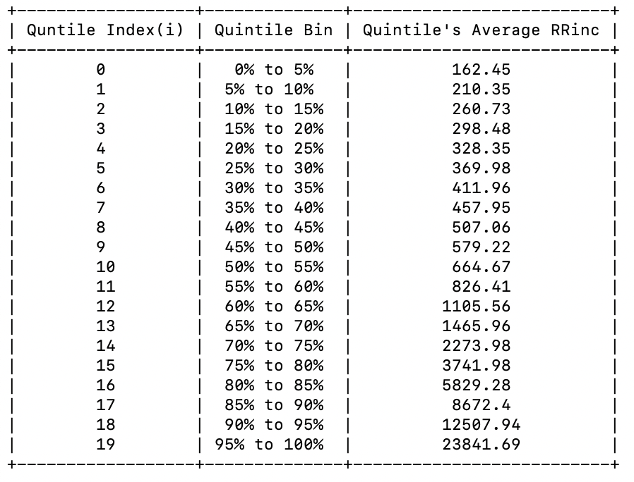

Stage 3

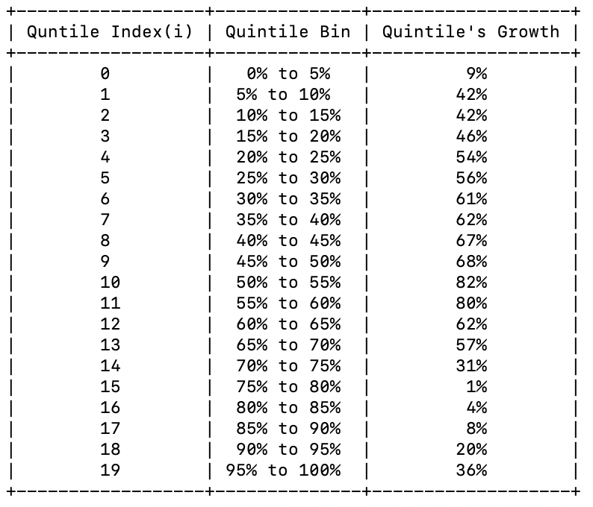

Stage 4

